Nagarjuna College of Information Technology
Shankhamul -09, Lalitpur
Full Marks: 60
Pass Marks: 30
Time: 3 hrs.
Pre-Board Examination-2080
BIM/ Third Semester/IT 237: Web Technology - I

Candidates are required to answer the questions in their own words as far as practicable
Group-A
Brief answer questions.
Attempt all questions. [10×1=10]
- Define Tags. Explain the types of tags?
- What do you understand by block elements?
- Differentiate between ordered list and unordered list.
- Which dialog box is used in JavaScript to take input?
- What is the use of indexOf() function in JavaScript?
- What are the valid data types supported by JSON?
- Why validation is done in client side?
- For what purpose float property is used?
- What is the purpose of using $(document ).ready () in Jquery?
- List HTML5 Sectioning Elements.
Group ‘B’
Short Answer Questions [5X3=15]
11. List differences between absolute and relative URLs. [3]
12. Describe CSS positioning with example? [3]
13. Explain BOM with example [3]
14. Write JavaScript Code to display multiplication table from 1 to 10 in a table. [3]
15. What is BOX model in CSS? Explain with suitable example.
16. What do you understand by Media Query. Explain with example. [3]
Group ‘C’
Short Answers Questions (5×3=15)
17. Write source code to generate following layout using div. [5]
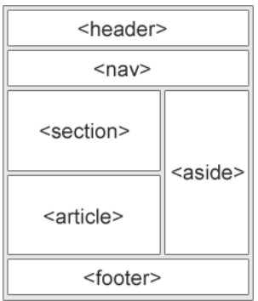
18. Explain Css selectors and its type with example.
19. Explain the purpose of XML DTD. Create a simple XML DTD for a bookstore that includes elements like book title, author, publication year, and price. Provide an XML document that conforms to this DTD.
20. Write a jQuery code snippet to select all paragraphs with the class "highlight" and change their background color to yellow.
Group ‘D’
Long Answer Question [2×10=20]
- i) Develop a login form in HTML that consists of username, password, confirm password, Email and login button.
ii) Validate Using JavaScript
A) Check weather both fields are not empty.
B) Password and Confirm password must match.
C) Password not less than 8 characters.
D) Email must contain @ and dot(.) symbol.
22. What is Ajax? Explain the concept of Asynchronous JavaScript and XML, its components, and how it works. Provide examples to illustrate its functionality.

